sunbridge letterhead

**Program Framework**

**Beijing ~ China and Detroit ~ USA**

**Co-Founders:**

**Bart Eddy: email:** [**barteddy45@gmail.com**](mailto:barteddy45@gmail.com)

**Han Fang: email: healworld0517@163.com**

sunbridge letterhead

***A Brief History***

The Sunbridge International Collaborative is a 501c3 non-profit organization that was co-founded by Han Fang from Beijing, China and Bart Eddy from Detroit, Michigan USA in 2012.

Ms. Han is a graduate of the prestigious Tsinghua University with a Masters Degree in Landscape Architecture, while Mr. Eddy is a long time educator and co-founder of Detroit Community Schools. The *Sunbridge International Collaborative* is an ***“experiential learning organization that allows children, young people and adults to discover their sense of mission and vision within the global community.”***

The Sunbridge International Collaborative cooperates with Detroit Community Schools and the University of Michigan School of Art and Design to run the “Entrepreneurship in Action” youth employment program for underserved youth; while in China, Sunbridge has conducted workshops for hands on learning for children, parents and teachers in Beijing, Chengdu and Guiyang. Sunbridge-China has worked with the China National Children’s Center and is currently represented by a team of colleagues from Tsinghua University. We are also engaged in conversations at the K-12/University levels to create and operate ‘Makers Space’ innovative labs that will be open to participants of all ages in both the USA and China.

The Sunbridge International Collaborative is dedicated to awakening children and young adults throughout the world to their sense of ‘calling’ in life, and we are inviting our friends and supporters from around the globe to join us in this transformational movement. Our work has received much inspiration from our colleague and friend, Johannes Matthiessen, from Stuttgart, Germany for his international work via Sacred Landscapes.

***Introduction***

As we grow in our knowledge and experience of how to bring a “hands-on” imagination more effectively into the world, this ‘working’ document or framework represents a distillation of lessons learned over a long period of time,

While it is possible to create many and varying “cool” projects within the scope of “*Learning by Doing”*, it is essential to remember that we are working with our youth in the context of self-discovery and engagement on behalf of the betterment of the individual and the world community. This document describes a pathway of work and learning that is both practical and imaginative in one breath. Practical in the sense that the students are acquiring tangible skills, and imaginative in the sense that they are evolving in terms of their self-awareness and global responsibility.

The Sunbridge Program is a training in the development of the Will, or those forces that are necessary to take action in the world that arise out of a moral and ethical foundation. The *Developmental Pathway of Work* carries a profound effect on the consciousness of our youth, and while much is left to the spontaneity of creative learning, it must also occur within the framework of a studio experience that is conducive to the development of all of these latent gifts. A Makers Space represents an opportunity for the community to come together and actively participate in a learning environment that foreshadows what may eventually become the ***School of the Future***.

***The Value of ‘Hands On’ Learning and ‘Learning by Doing’***

As schools and universities struggle to find meaningful ways to engage student enthusiasm for and interest in the active learning that bridges the gap between rote memorization and imaginative thinking, the value of ‘hands on’ learning cannot be overstated. The value of ‘Learning by Doing’ is a powerful set of dynamics that engages the *active will* of the students while emphasizing *innovation and creativity* as a way to connect and uplift---socially and substantively. What follows is a brief synopsis of current educational practices that embrace applied academics through practical work/learning endeavors that are enriched by the artistic and imaginative disciplines.

* **Experiential Learning**: Students learn more effectively when they are engaged in an experience that really matters to them. Experiential learning can be implemented throughout any academic discipline as long as it exemplifies a connection with problems and challenges that are found in the “real world” (i.e. climate change as part of the science curriculum.)
* **Arts and Crafts**: Students gain a sense of their own creativity and practice the development of their imaginative capacities through the immersion in the arts and the crafts. It allows them to bring their ‘vision’ into ‘action’ and exemplifies a kind of training that will help them to discover how to bring their dreams into reality.
* **S.T.E.A.M**: Students explore the range of possibilities within the context of the Science, Technology, Engineering, Arts and Math curriculums. This facilitates a cross-disciplinary approach to thinking with tactile exercises via micro-kits and advanced technologies.
* **Makers Space**: Students and community members come together in a refurbished shop/studio space to create and innovate. For instance, a Makers Space can be dedicated to many activities such as Woodwork, Metalwork, Screen Printing, Audio Gear, Video Production, Rapid Prototyping, Market Gardening, etc.
* **Entrepreneurship**: Students learn the fundamentals of entrepreneurship by starting and running their own school-based businesses that are primarily dedicated to providing services to the community. This becomes a training ground for social entrepreneurship with a strong community service component.
* **Place Based Education**: Students practice a type of education that bears a direct relationship to the community in which they live. Examples include environmental issues that affect the community, a study of plant life and demographics, or local history and its effects on the present day. (See Exhibit A: the Social Entrepreneurship and Sustainability Curriculum.)

***Educational Methods***

When a student enters into a studio workspace, they are stepping into an educational training center that will allow them to transform the way they look at the world and discover who they are in the process. Four levels of training characterize the Developmental Pathway of Work: Apprentice, Journeyman, Master and Entrepreneur.

**Developmental Pathway of Work**

(The Stages of Student Growth and Development)

**The Apprentice**: Students first commit themselves to doing the physical work itself and the personal effort/discipline in creating something. In learning by observation and becoming engaged in the “doing”, the Apprentice Worker experiences the mentoring and modeling of the other team members.

**The Journeyman**: Students learn how to work skillfully with the tools and the materials that are needed to accomplish the work and to accept the guidance of the teacher.

**The Master**: Once the student has mastered the work, he or she becomes the teacher and instructs others in the techniques and processes.

**The Entrepreneur**: At this level, the student becomes an innovator, creating new solutions and businesses designed to solve social, economic and environmental problems in their community. As Team Worker, the student recognizes that entrepreneurship finds its place and purpose in the community as part of a broader collective effort.

**Developmental Pathway of Work**

**(Training the “Will” Through Work)**

***“Awaken the Calling”***

|  |  |  |  |
| --- | --- | --- | --- |
| **Entrepreneur** | **Innovation**  **(Creation out of Nothing)** | **Social and Technological Entrepreneur** | **Community Production; Start Up** |
| **Master** | **Expertise / “Know How”** | **Mechanic Artisan** | **Production Facility; Factory** |
| **Journeyman** | **Right Rhythms**  **And Processes** | **Craftsman** | **Shop** |
| **Apprentice** | **Physical** | **Laborer** | **Field** |

The next section further defines the Metrics of Measurement that will be used to assess student learning and achievement. Defined as “Qualitative Metrics”, student assessments are primarily based upon the observations of those with whom they work directly. During the course of the training, it is possible for the students to exhibit characteristics from each of the levels, while maintaining a central expression on one.

**Developmental Pathway of Work**

**(Stages of Student Growth and Development)**

***Qualitative Metrics***

**The Apprentice**: Students first commit themselves to doing the physical work itself and the personal effort/discipline in creating something. In learning by observation and becoming engaged in the “doing”, the Apprentice Worker experiences the mentoring and modeling of the other team members. The students will:

* Identify the basic tools used in the various studio settings;
* Learn the proper use of tools and safety measures to safeguard themselves and others;
* Demonstrate the basic techniques required to work in each studio;
* Develop focus and concentration;
* Work with consistency and persistence until the task is completed;
* Make mistakes and learn from their mistakes;
* Maintain health and well-being in order to work effectively;
* Show a willingness to work in cooperation with the instructor and the other students;
* Prepare for work both physically and mentally.

**The Journeyman**: Students work skillfully with tools and materials and accept the guidance of the teacher. The students will:

* Gain proficiency and competence in tool usage that allows for project experimentation, innovation and creativity.
* Be able to order and purchase supplies and equipment for the studio.
* Develop entry-level understanding of financial management and operations.
* Follow a design/build process from beginning to end.
* Provide leadership and support for Apprentice students as an aid to project completion.
* Receive training in the techniques of Team Building
* Integrate a basic understanding of social entrepreneurship, community building and its relationship to hands-on learning.

**The Master**: Upon mastery of the work, the student becomes the teacher and instructs others in the techniques and processes. The students will:

* Achieve responsibility for the operation of all shop/studio operations.
* Organize workday and schedule.
* Take customer orders and interface with the public.
* Demonstrate mastery of materials, supplies and equipment.
* Provide peer-to-peer training for entry-level apprentices and journeyman.
* Organize and conduct workshops for students in other locations throughout the community.
* Engage in public speaking at community and citywide events.
* Qualify for international/study abroad work-learning experience in a studio discipline.

**The Entrepreneur**: At this level, the student becomes an innovator, creating new solutions and businesses designed to solve social, economic and environmental problems in their community. As a team worker, the student gains the recognition that entrepreneurship finds its place and purpose in the community as part of a broader collective effort. The students will:

* Examine a wide range of entrepreneurial case studies of ‘start ups’ in the technological fields that are both industry related and defined by their commitment to social entrepreneurship.
* Complete “Vision to Action” training and support unit.
* Design and implement a ‘start up’ endeavor.
* Brand and market product into the public domain.
* Train in the use of advanced technological tools (3-D fabricators, laser cutters) and S.T.E.A.M. programming.
* Integrate artistic components into all activities.
* Communicate creative and innovative ideas to all Team Members for examination and validation.

***Cultivating “Habits of Mind”***

This section is adapted from Costa, A and Kallick, B (2000) ***Habits of Mind*** whose research becomes a perfect fit for the studio-based, experiential learning platforms. ‘Habits of Mind’ transcend the basic subject matter taught within a regular school setting and are widely applicable to all endeavors, including governments, CBO’s and corporate entities. When an organization develops these practices, then the level of authenticity, ethical behavior, integrity and disciplined choice making is increased. Indeed, these qualities stand-alone and can be practiced throughout life in any setting. What sets them apart is the idea that the cultivation of a habit will eventually lead to perfected practice that occurs as a natural part of human behavior. Our challenge is to create those experiences whereby young people can have an opportunity to put the “Habits of Mind” into practice.

**Creating, Imagining and Innovating**: Students will learn to become innovators through problem solving and creative thinking. Throughout the Developmental Pathway of Work, there is the continuous challenge to think more flexibly.

**Resilience**: They will develop the Perseverance (the Will) to carry out deeds in the world from the beginning to the end. Resilience also means that they will learn to overcome all kinds of hardships within the context of our training studios and learn to accept failure as a required step in learning to do something the right way. Craftsmanship often requires continuous reworking.

**Focus and Concentration for Accuracy and Precision**: All of our hands on work demands focus and concentration in order to complete the task. And this is why we look at the different levels of work from Apprentice to Journeyman to Master to Entrepreneur. Each stage represents another level of attainment. Craftsmanship includes exactness, precision, accuracy, correctness, faithfulness and fidelity.

**Wonder and Awe and Devotion**: Much of this is dependent upon the enthusiasm and interest that the young person is able to ‘self-generate’ through their efforts. There can be nothing more satisfying than craftsmanship beautifully executed, and the wonder and awe of achievement will eventually allow the young person to look at the world in a different way. A devoted worker learns to love what they are doing.

**Work Ethic**: All activities will help to develop the capacity to work well (efficiently and competently) and to work effectively in the world. Developing a “work ethic” means that a person will learn to do high quality work and to take pride in their craftsmanship.

**Teamwork**: In a studio situation, everything that we do requires “teamwork” in the sense that the Journeyman helps the Apprentice and the Master helps the Journeyman. There is a continuous interchange of competency and knowledge. This helps to develop a ‘social conscience’ through the service performed for each other.

**Thinking Interdependently**: Many projects require the input of all group members in order to problem solve and put creativity into action. This means that Team Members must be able to listen objectively, put their egos aside and work towards the greater good. Empathy, compassion and leadership are all attributes of interdependent work. Cooperation and collaboration are the keys to interdependent thinking.

**Social Entrepreneurship**: Learning to think creatively encourages the young person to expand their horizons and view the challenges of the world in a different light. Out of this, he or she begins to recognize the ‘signs of the times’ and determine ways to take effective action in the world.

**Vision to Action:** Students will learn to take a concept design and bring it into some form of worldly expression. Developing the capacity for self-initiated activity represents a training of the “Will” to carry out deeds in the world.

**Lifelong Learning**: The true educator knows that each young person that stands before him or her has a unique “calling” in life, and that it is the educator’s responsibility to help to awaken the dreams and visions that are the signposts in the life of a young person.

***Educational Series***

***(Lectures, Seminars and Workshop Offerings)***

All of these offerings are adaptable to place and circumstance and through one form or another have been put into practice during the course of many years. The overriding theme concerns itself with the development of the ***School of the Future***, which will be outlined in the next section.

**The Organization:**

Phases of Organizational Growth and Development:

Life Phases of the Organization:

Organizational Biography:

**The Educational System:**

Phases of Human Development: (Child to Adult)

Cultivating the Thinking, Feeling and Willing: Systemic Approach to a Child Study: (Understanding the Whole Child)

The Pathway to Imagination, Inspiration and Intuition:

Age Appropriate Learning: (Classroom Exercises and Lessons)

Awakening Creativity and Imagination:

Training the Will to take Action in the World:

Vision to Action: “Keepers of the Flame”:

Connecting the ‘Doing’ with the development of Thinking:

**The International Community:**

Global Discovery, Social Entrepreneurship and Community Transformation:

Global Discovery Forum:

The Developmental Pathway of Work:

‘Sheathes of the Human Being’: (Wisdom from the East and West)

Experiential Learning and Exercises in Community Engagement:

Finding One’s Calling in Life: (Mission and Vision)

Igniting the Fires of Enthusiasm for 'Learning by Doing’:

Opening the Heart to a World of Possibility and Opportunity:

Future ‘Golden Seed’ and the Common Heart of Humanity:

**Experiential Learning Studios**

Exploring the Nature of Arts and Crafts:

Demonstrating the Power and Joy of making something with the Hands:

Parent and Child Workshops:

***School of the Future***

Cross Cultural

Intergenerational

International

“Maker’s Space” for Identity Building

Sanctuary for Work and Learning

Awakens the “Calling” in Life

Experiential and Holistic

Social Entrepreneurship and Community Transformation

Innovative Leadership

‘Living Thinking’

The ***School of the Future*** is an active imagination that is beginning to find its way from out of the Future and into the Present. In its root and essence, it represents those ideals, which we know in our ‘heart of hearts’ will provide an extraordinary and uplifting pathway to self-discovery. As it grows into the world, it will become the modern day temple of initiation that will help our young people to navigate their way through the multitude of challenges that are confronting our modern culture. And when it flowers, it will spread the seeds of Truth, Beauty and Goodness out of which it was founded to every corner of the world.

***Examples of ‘Hands On’ Learning from China and the USA***

**Industrial Trike Repair-Detroit Kindergarten ~ Beijing**

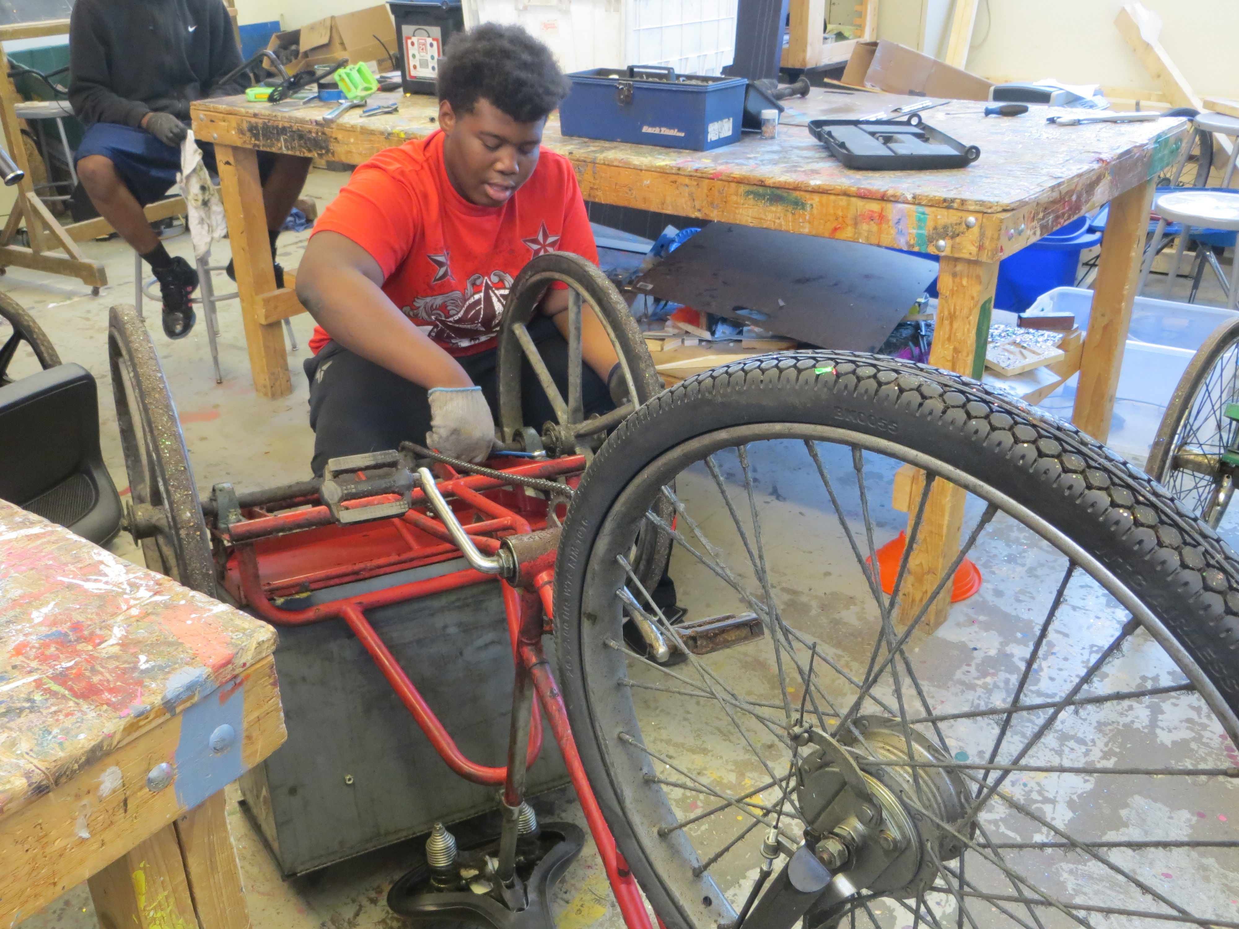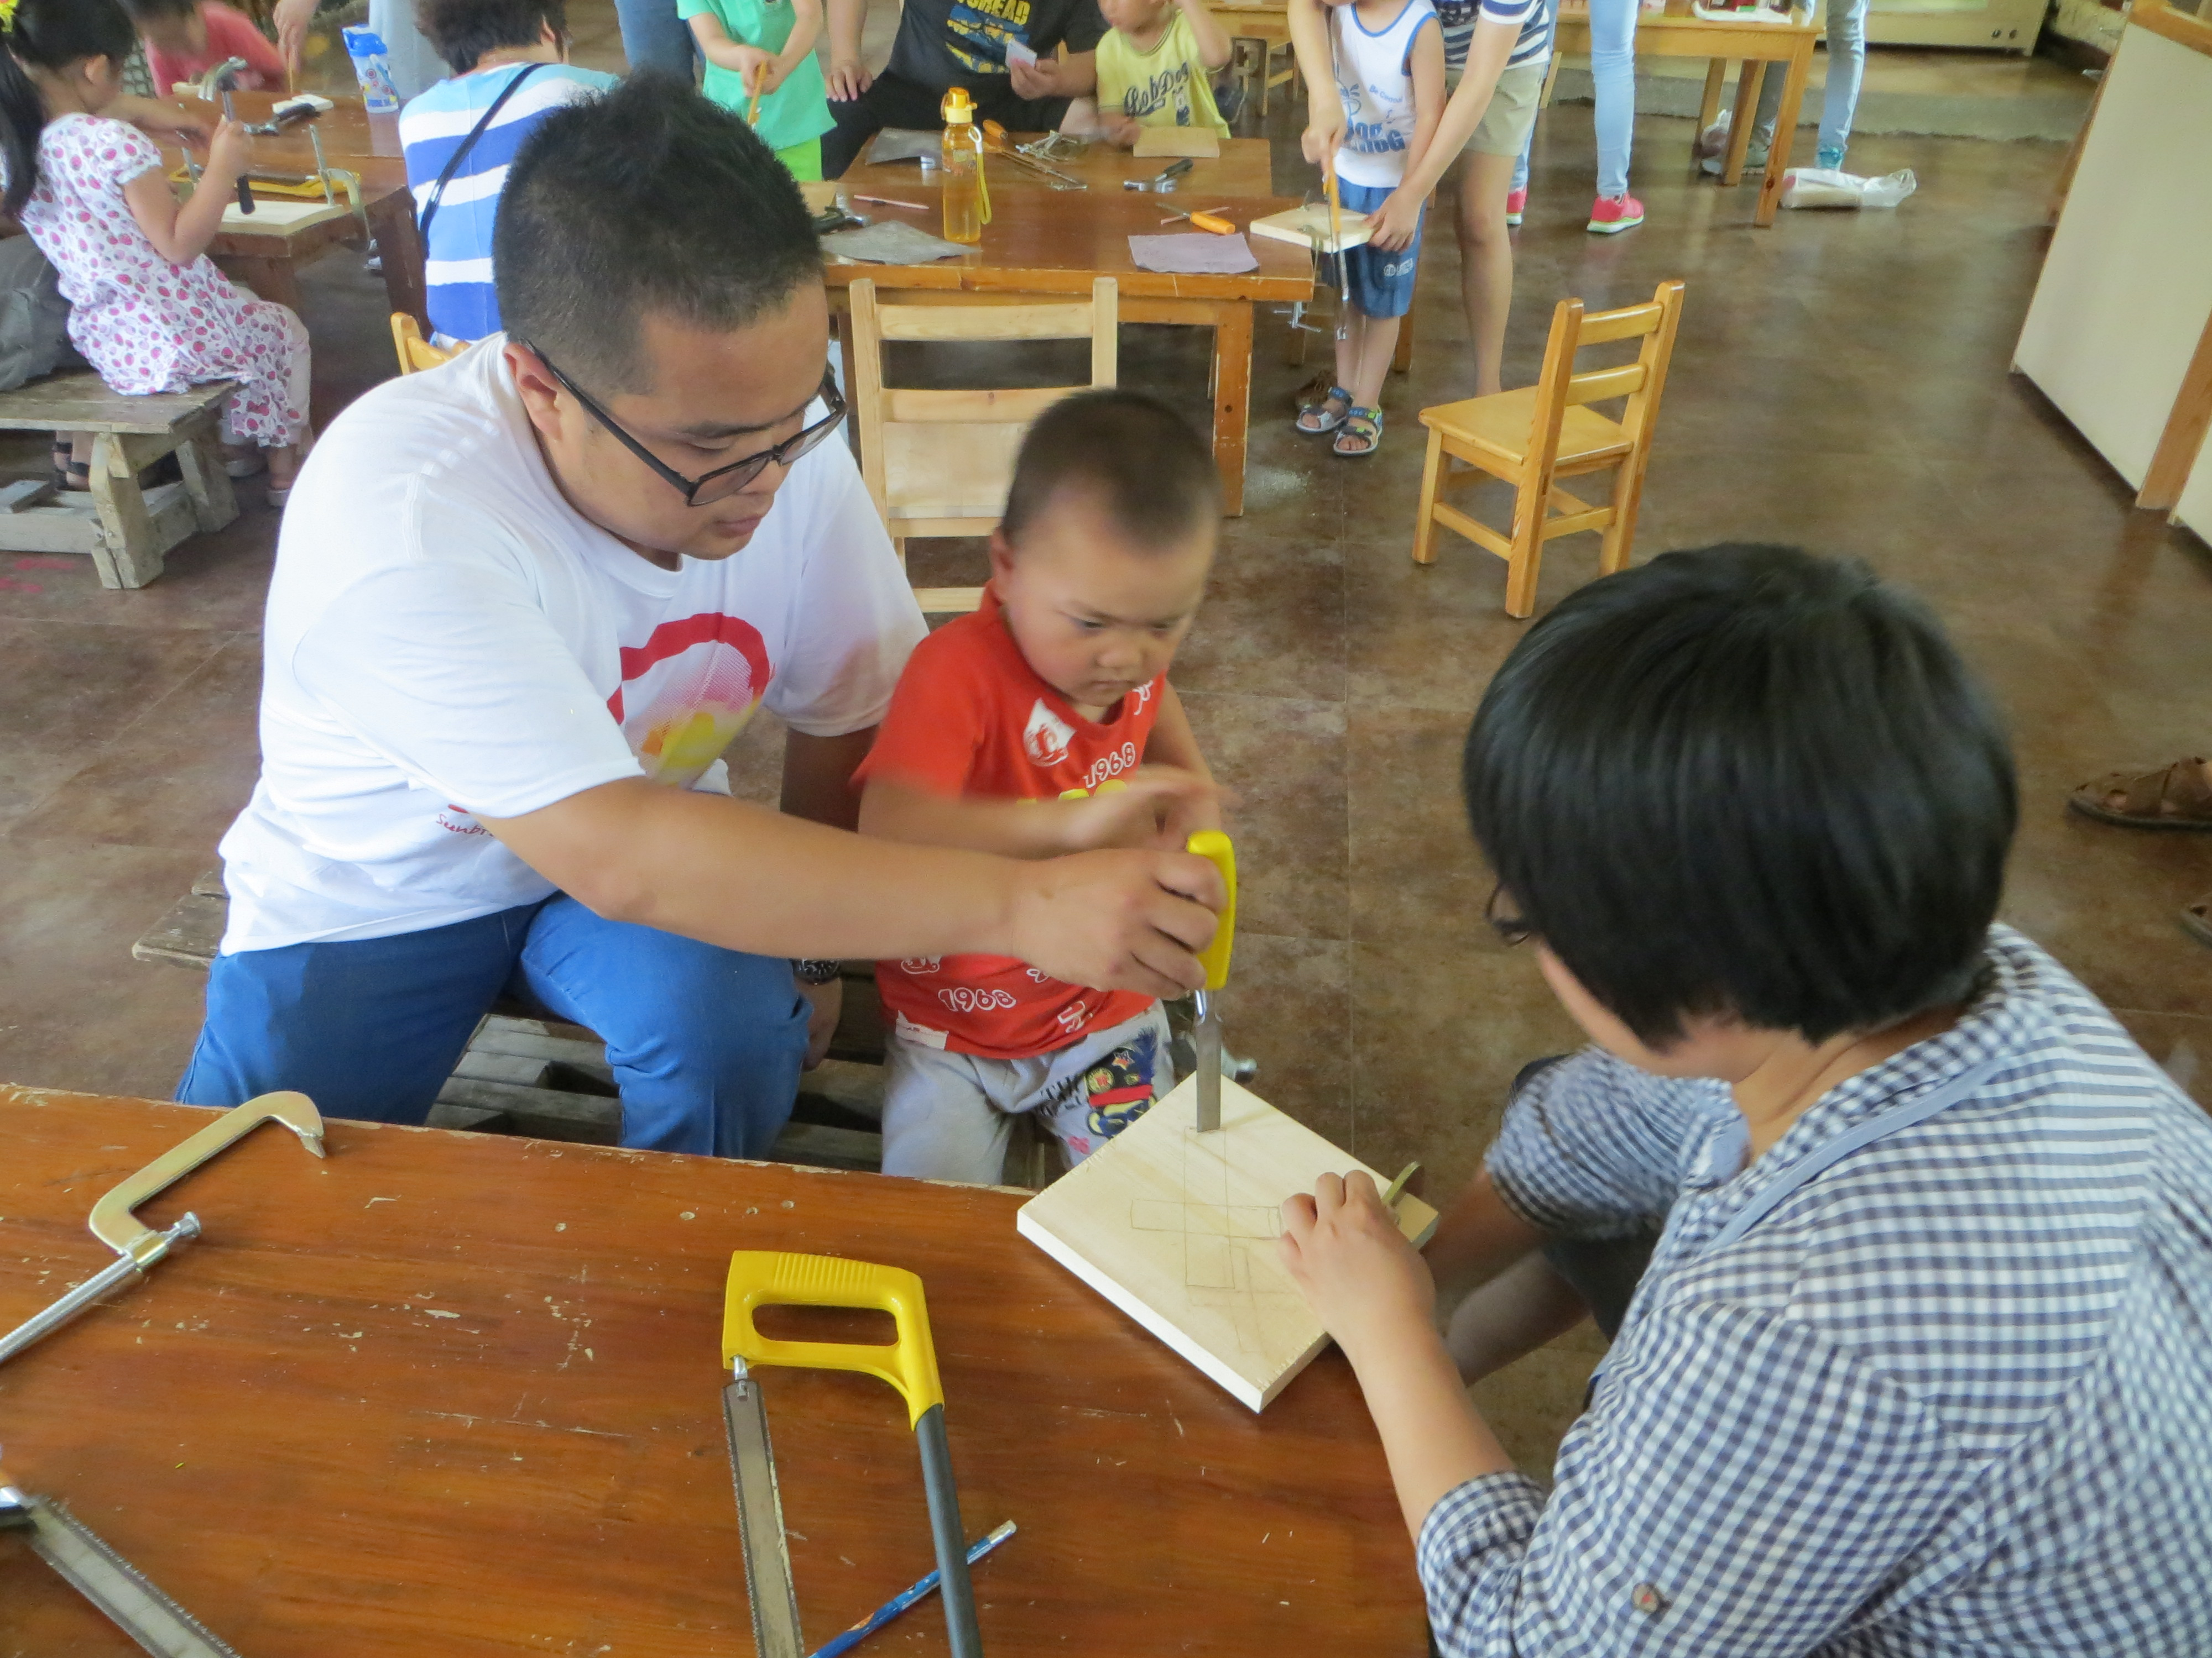

**Student Instructor ~ Detroit**

***i***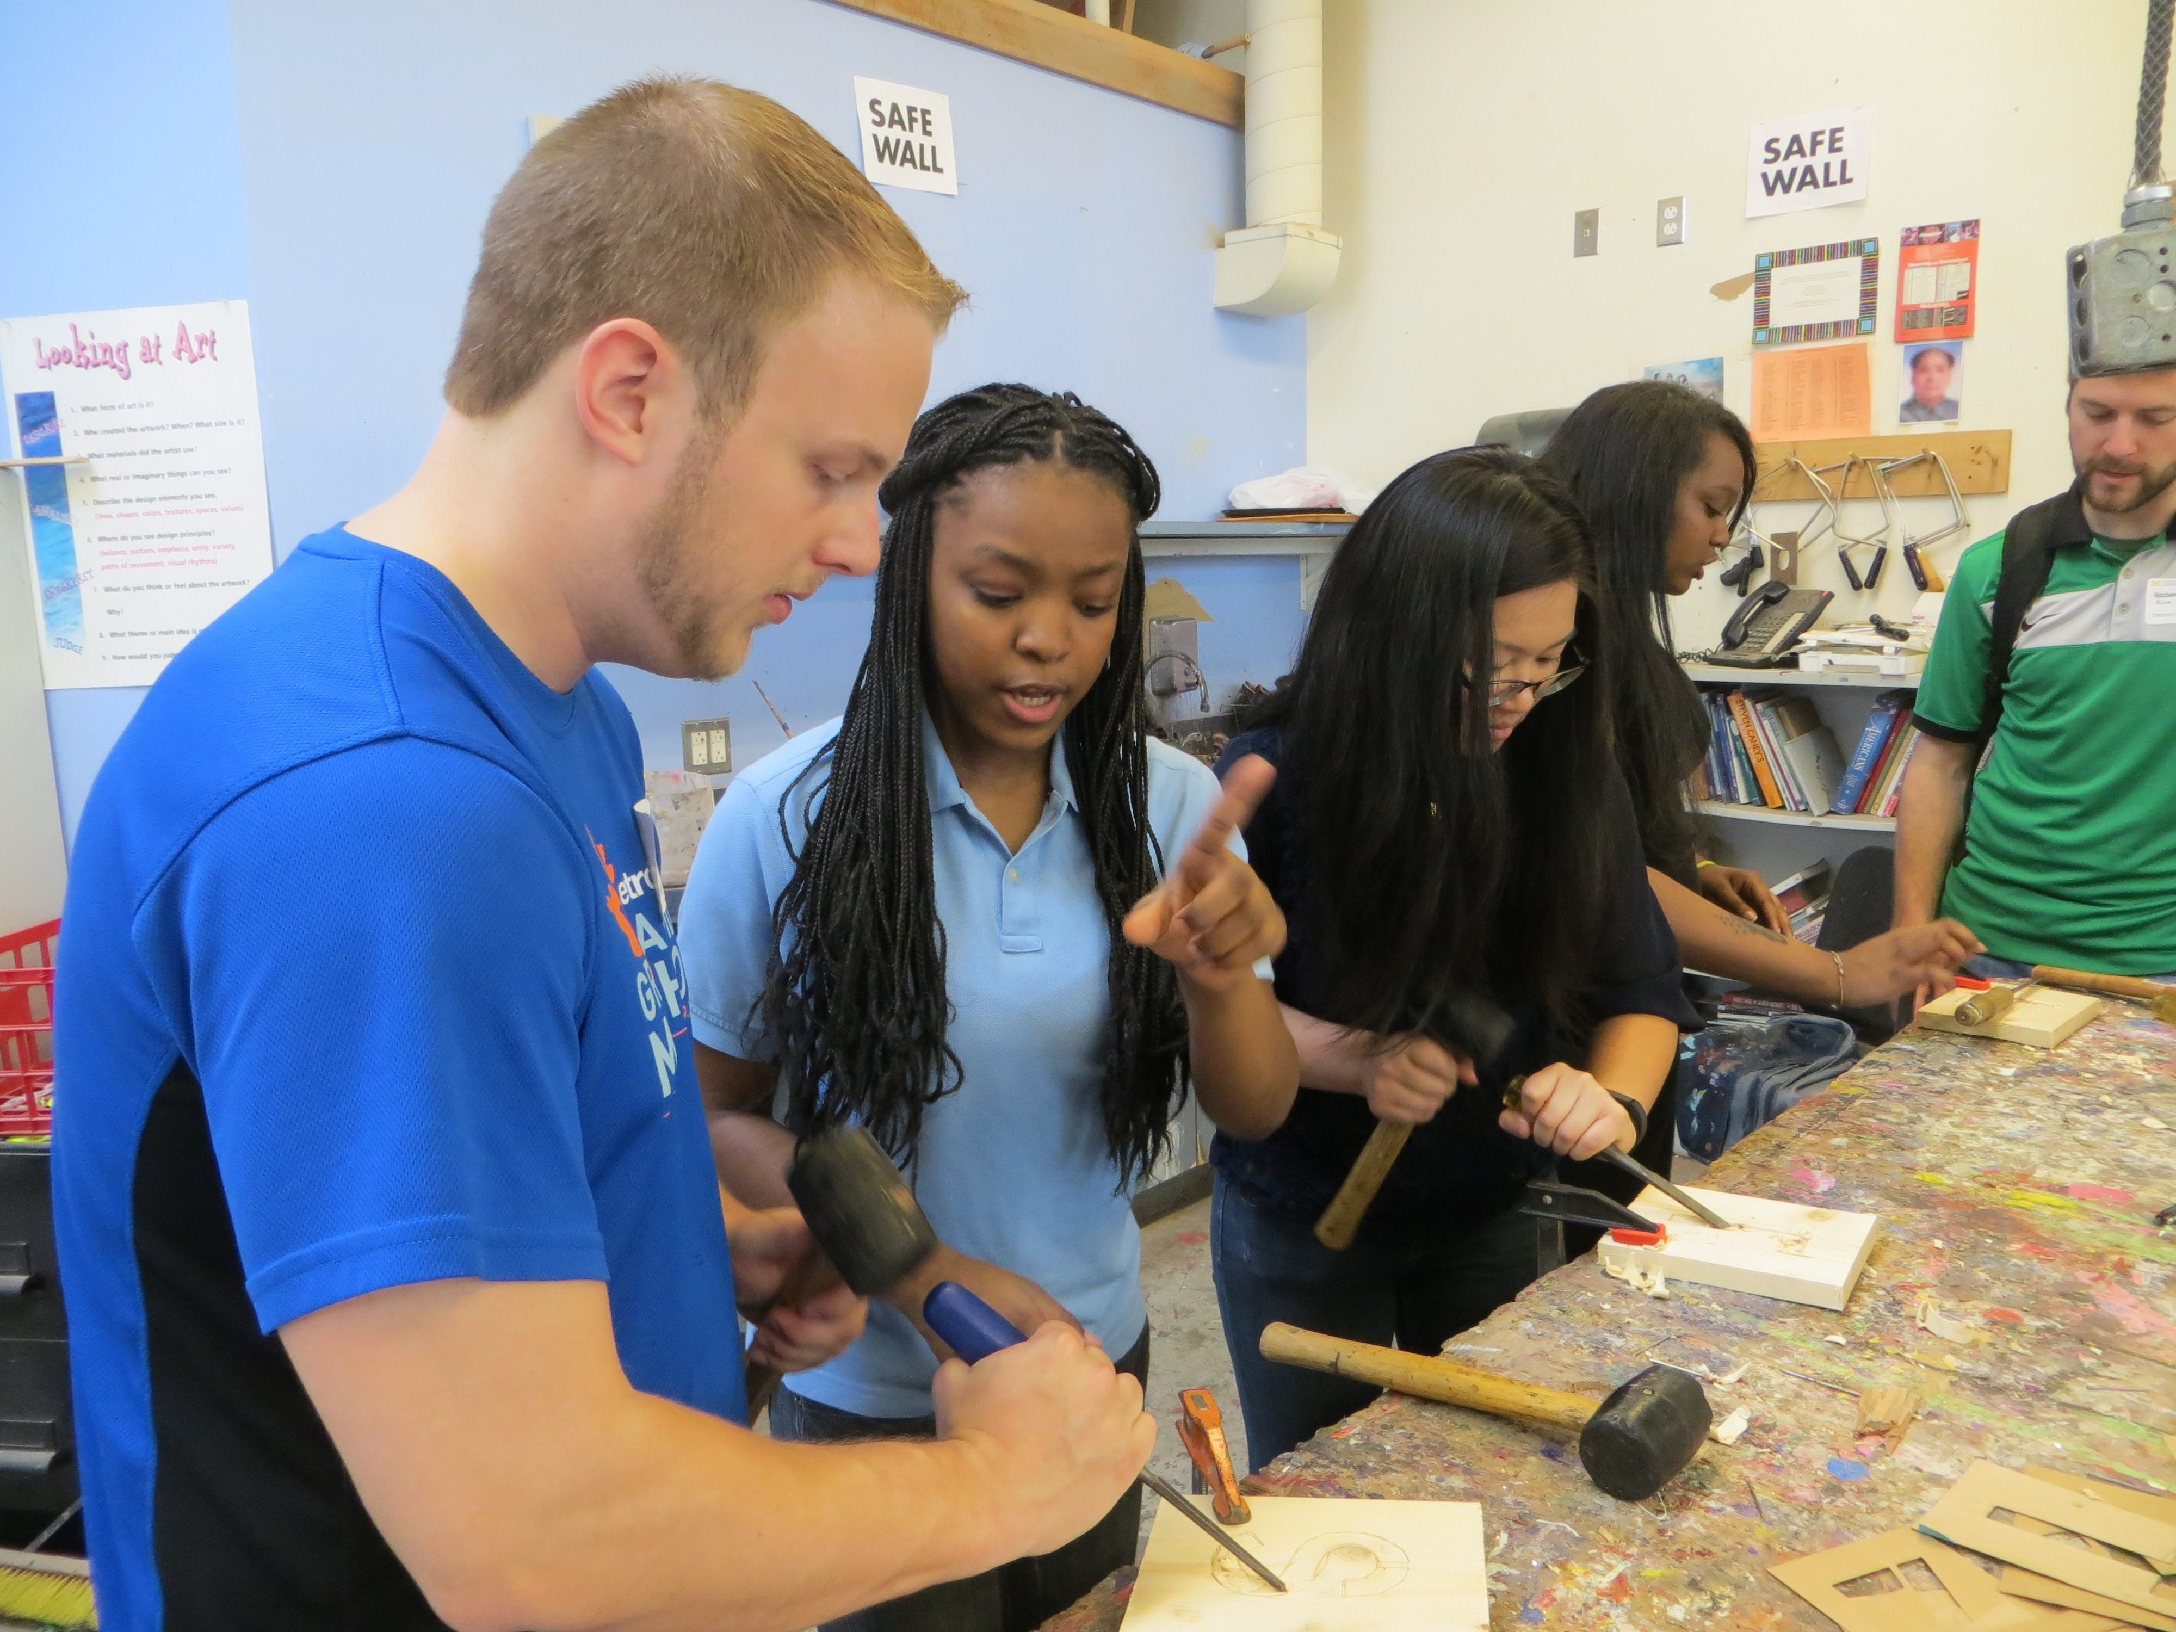

**Sichuan Province**

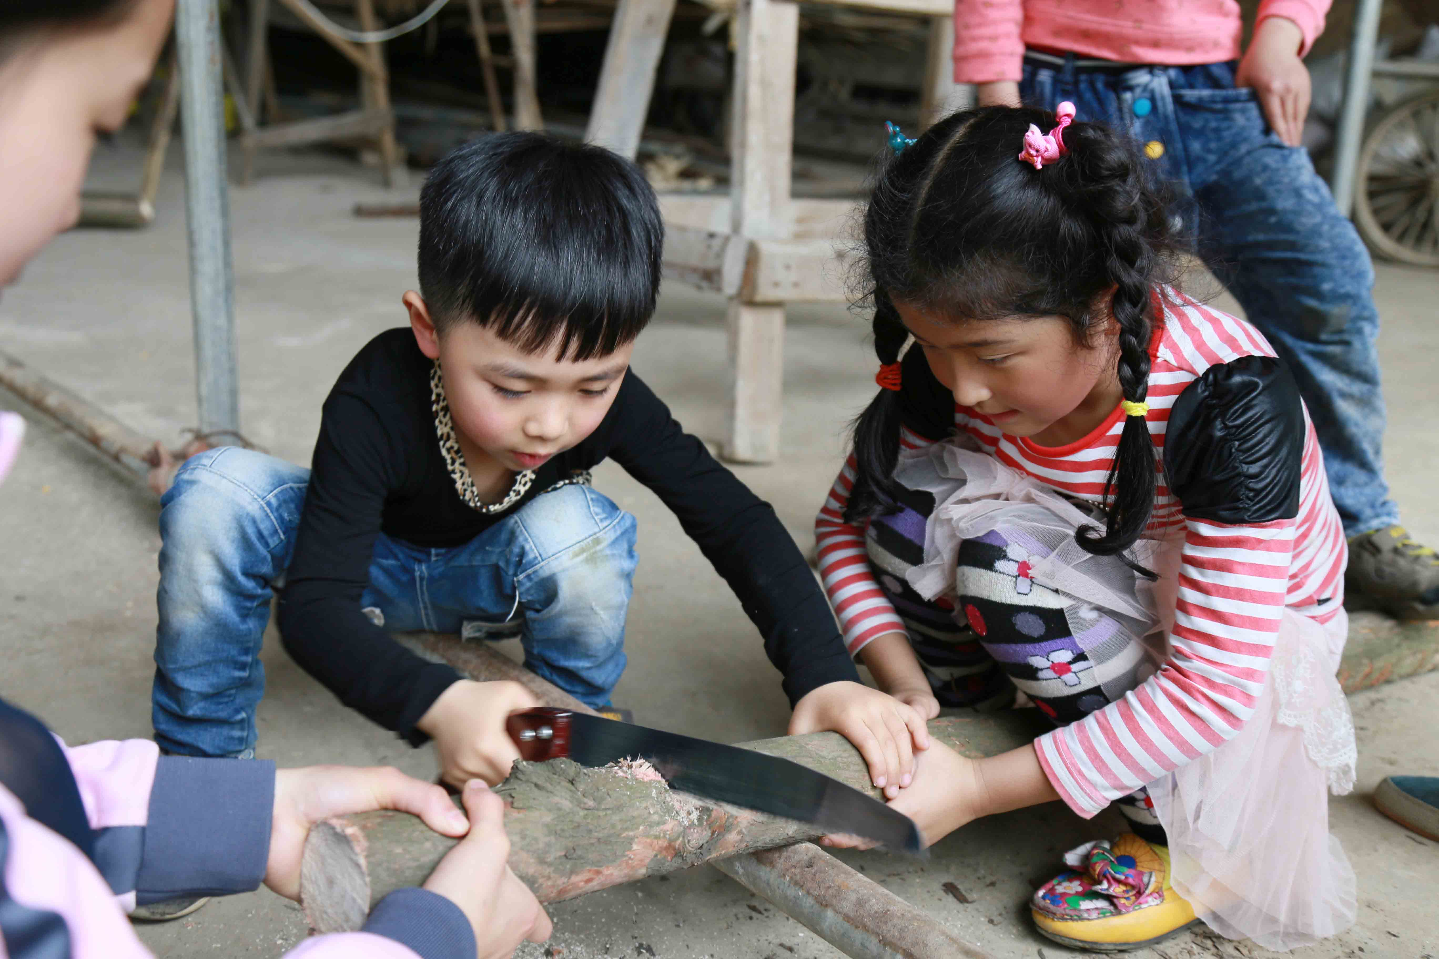

**Guiyang ~ CNCC ~ Children’s Camp DCS and U of M Ross School of Business**

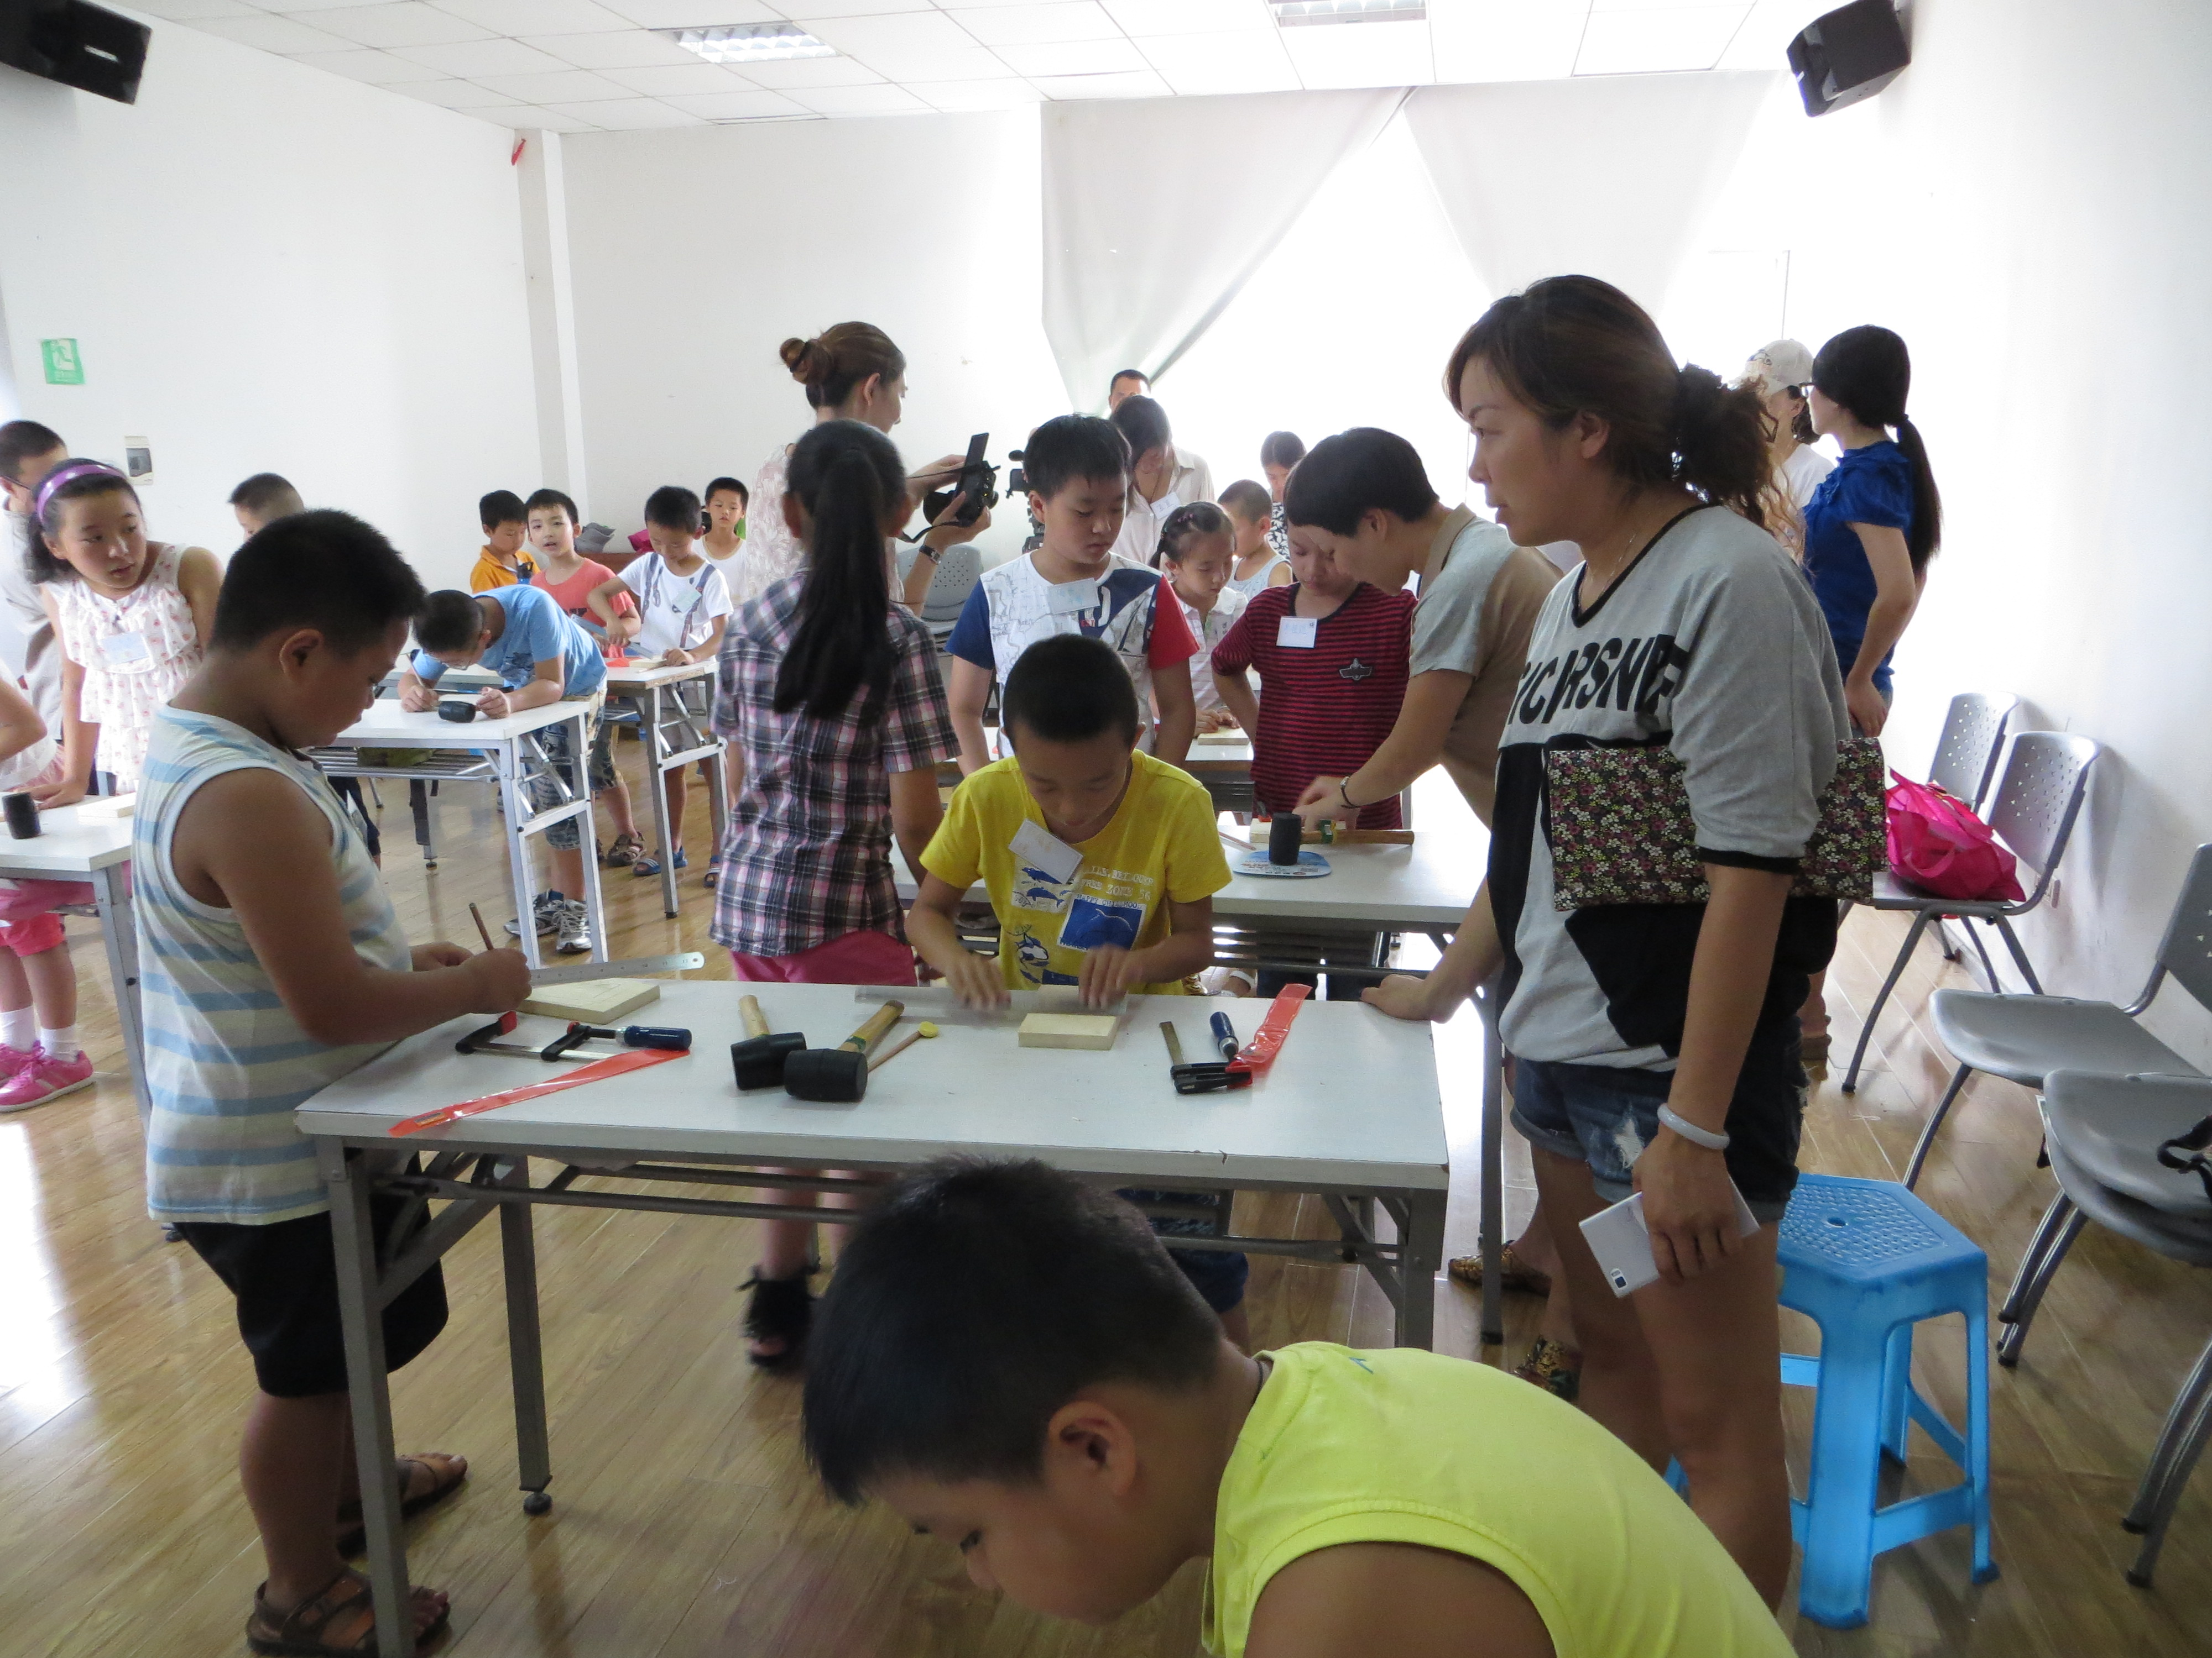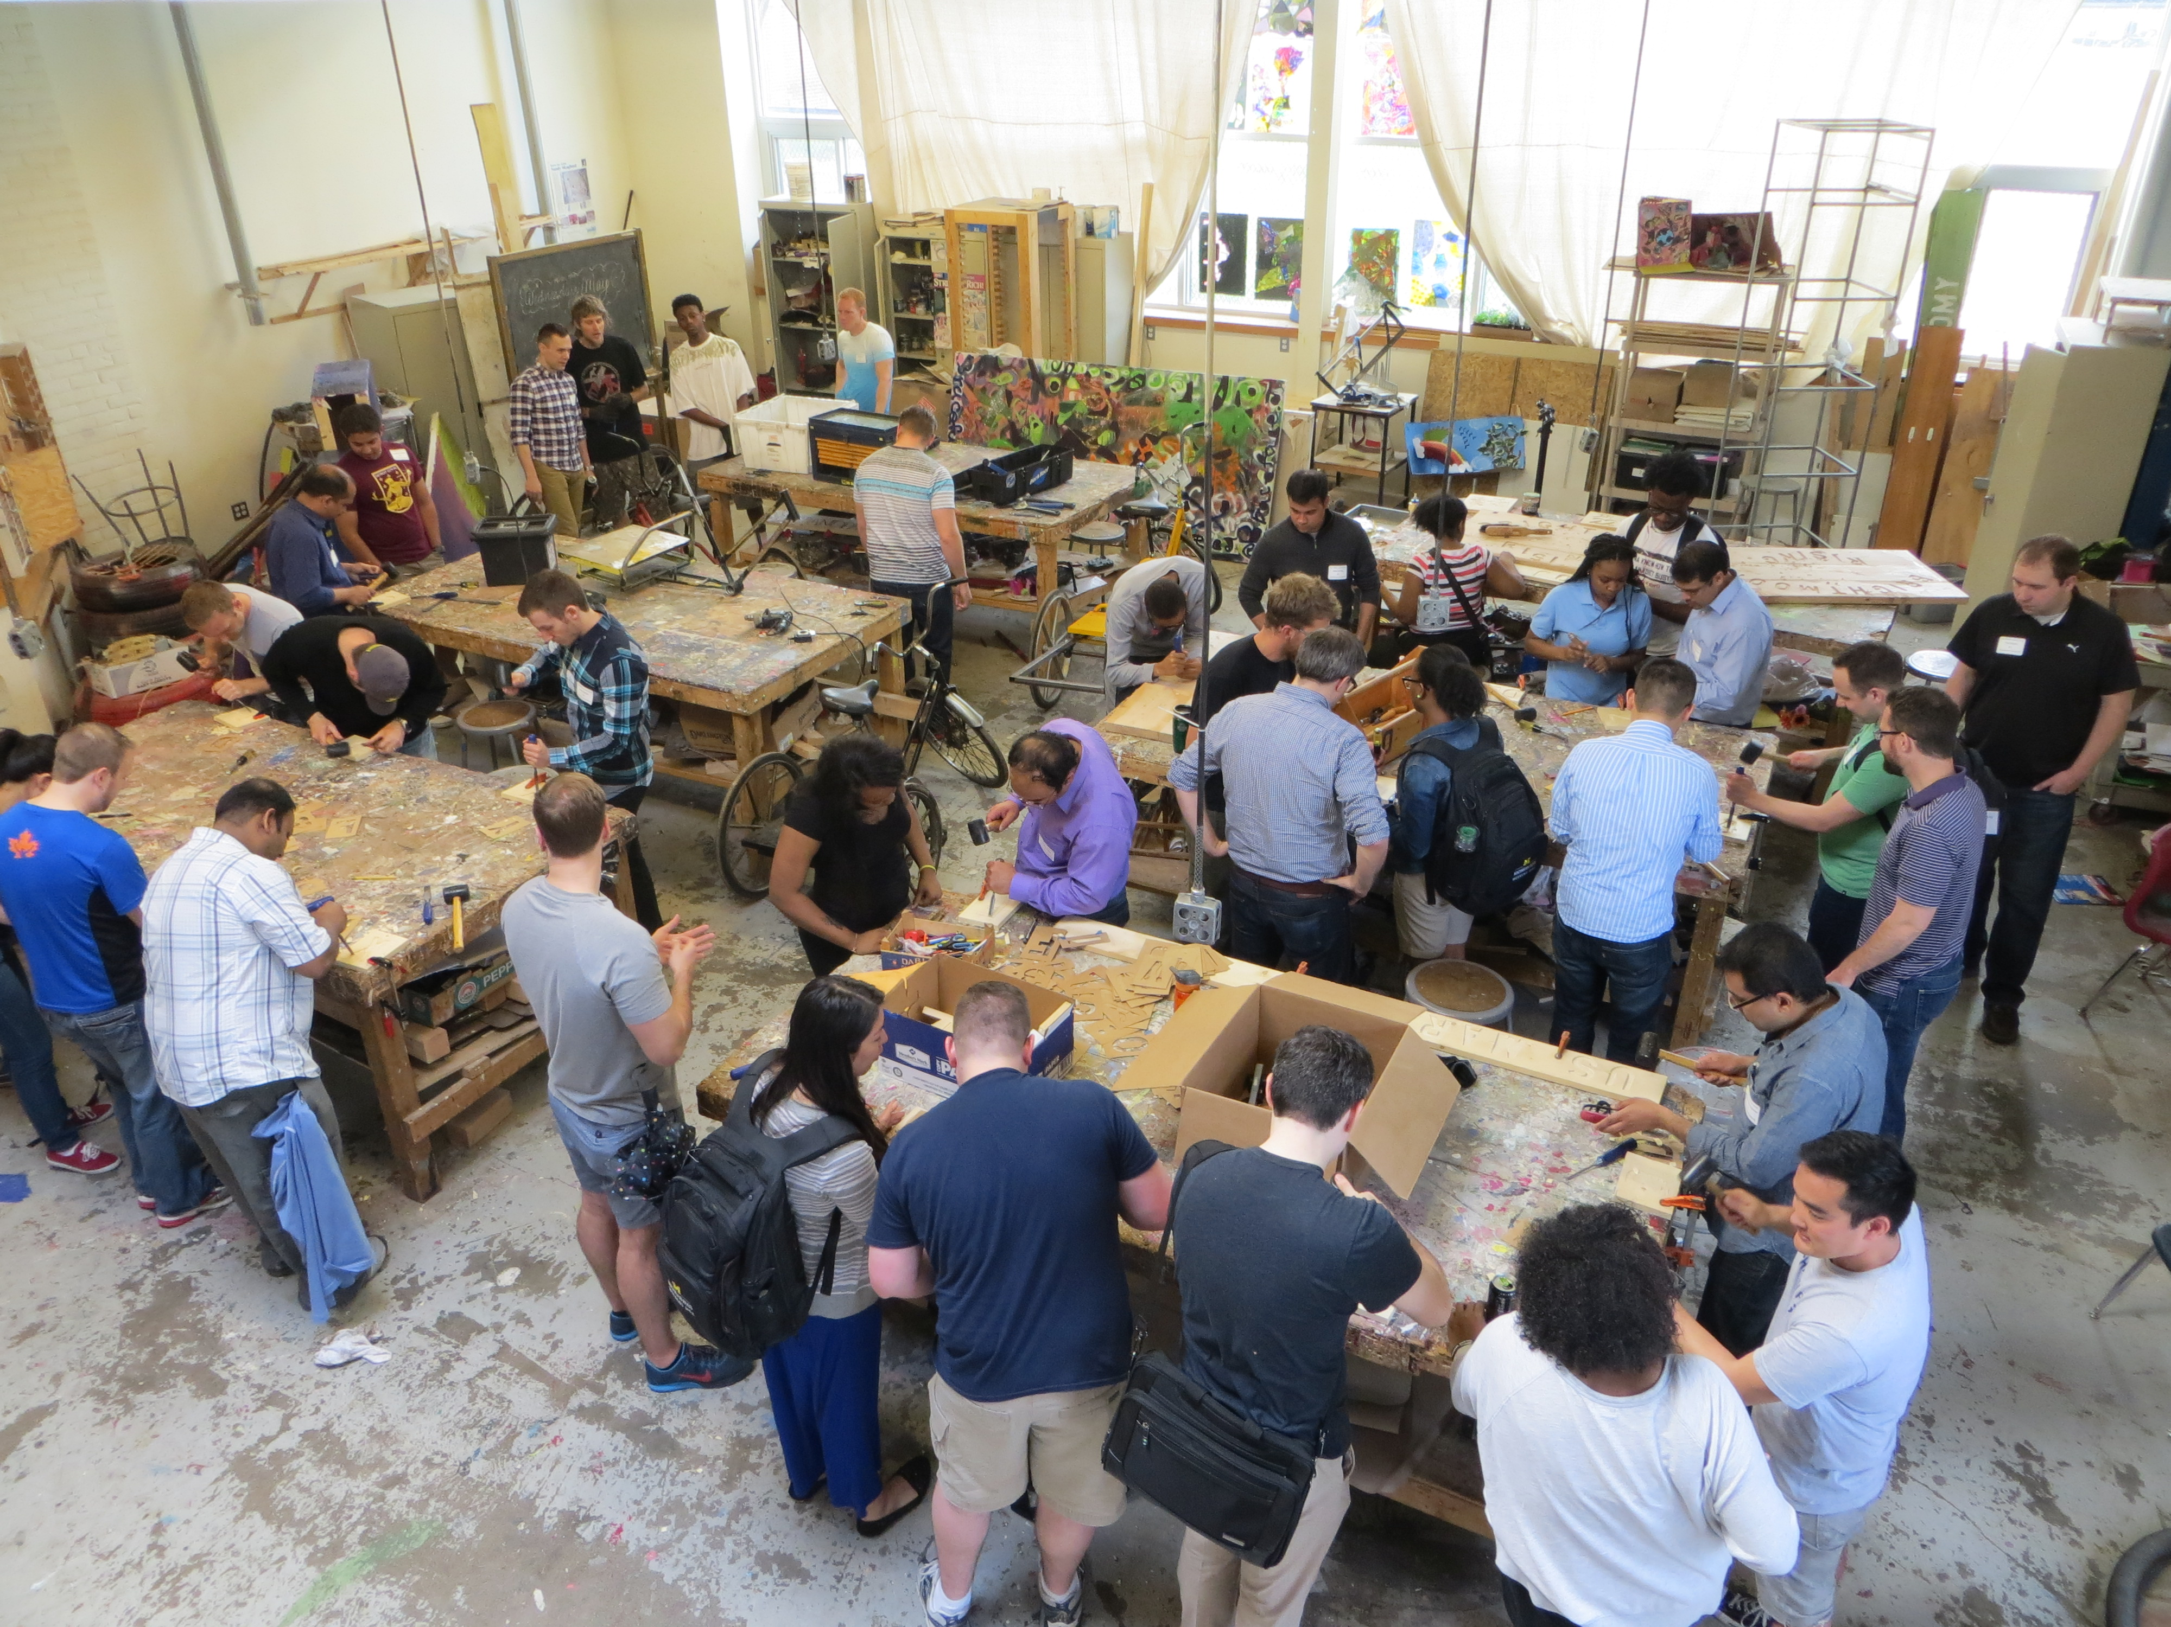

***The Future of Sunbridge Work***

**International Studio Training Centers:** It is important to firmly establish the work in both China and the USA through studio training centers. These ‘studios’ can take a variety of forms but can also be seen as being in alignment with the Makers Space movement. These centers are devoted to hands on learning, serve multiple ages and maintain a physical space in the host country. With the firm establishment of the training center and the experimental/experiential work that ensues, we will create the necessary platform out of which the Sunbridge movement will grow and flourish in the international community. These efforts will be locally sustained, and this is why partnerships with organizations, businesses, schools and universities are incumbent upon its success.

**Year Round Programming:** In addition to the weekend workshops and seminars that will begin to ‘spread the word’, it is now time to consider a year round program that will primarily operate out of the studio training center. Everything that has been previously outlined in this working document is designed for long-term involvement with our youth. The next phase of our work together will be to create an international curriculum that is relevant to young people in both countries. In Exhibit A to this working document, a course outline that was developed by Creative Change Educational Solutions in cooperation with Detroit Community Schools has been attached. The course outline is the first small step in the development of the ***Sustainability and Social Entrepreneurship*** curriculum.

**International Student Exchange and Cultural Immersion:**

**Global Discovery and Social Entrepreneurship** is designed as an “experiential” educational program that will explore the key issues and concepts that are operative on a global level and that are responsible for shaping our collective future. On a practical/experiential level, this course will focus on hands on creative immersion in challenges and opportunities facing two of the world’s major cities: Detroit and Beijing. Through electronic media and cultural exchange the young people from the USA and China will come together to work and learn in a cooperative exchange setting.

**Community Transformation and Global Discovery Forum:** The Global Discovery Forum will present the ideas and the context out of which these issues connect with global concerns, and Community Transformation will exemplify the practice of taking direct action in the local community. Taken together, we will engage in reciprocal and international dialogue, promote sustainable and creative communities, explore creative place making and find innovation through creative entrepreneurship.

**Sunbridge Fellowship:** This is an 18-month “Bridge Year/Gap Year” program serving young people with great promise who are searching for meaning and direction in their lives. This program will incorporate applied academics; the arts and the social/community building aspects of learning and doing; and the direct application of their experiences through entrepreneurial endeavors and internships. The ‘Fellowship’ will incorporate all of the above-mentioned future considerations (International Studio Training Centers ~ Year Round Programming ~ International Exchange and Cultural Immersion)

***Conclusion and Next Steps***

The foundation for this program is a compilation of many years of work through varying forms of expression. The latest iteration expands the focus and scope of these endeavors into the international community without losing sight of the importance of the time and place from which it has come. The ever-evolving mission and vision will never leave one place in favor of another but will incorporate all of the lessons learned in order to serve more and more children and young people throughout the world. So the next steps become a natural sequence in the development of the work of the Sunbridge International Collaborative. And they are:

1. Anchor the Studio concept in the Makers Space as a center of active “doing”.
2. Work collaboratively and comprehensively in both China and the USA out of the University of Michigan and Tsinghua University to enhance and grow the Sunbridge International Collaborative whose mission reflects the following: *“experiential learning organization that allows children, young people and adults to discover their sense of mission and vision within the global community.”*
3. Create a curriculum and design course descriptions that represent our endeavors as an international School of the Future. This will be a ‘place-based’ curriculum born out of the needs of our respective cultures.
4. Engage the Sunbridge International Collaborative to represent the mutual interests of all partners and to actively pursue the building of effective partnerships in accord with our mission and vision.
5. Obtain the necessary resources to operate effectively.